Candidate’s Administrative Data
IDENTIFICATION FORM:

Name of candidate:
Address:
Post code:
Tel.
Fax:
E-mail:
Website (if applicable):
Legal status:
Registration number:
VAT number:
Name and contact details of contact person for this tender:
Name and title of legal representative:
Signature of legal representative:

Annexes: I LEF and BAF
II Exclusion Criteria Form
III Financial and Economic Capacity Overview Form
IV Contract Reference Form
V Statement on Average Annual Permanent Staff Members
VI Curriculum Vitae
VII Power of Attorney
VIII Subcontractor / Letter of Intent

Model financial identification form
(to be completed by the tenderer and his or her financial institution)

The tenderer's attention is drawn to the fact that this document is a model, and a specific form for each Member State is available at the following Internet address:
http://ec.europa.eu/budget/contracts_grants/info_contracts/financial_id/financial_id_en.cfm

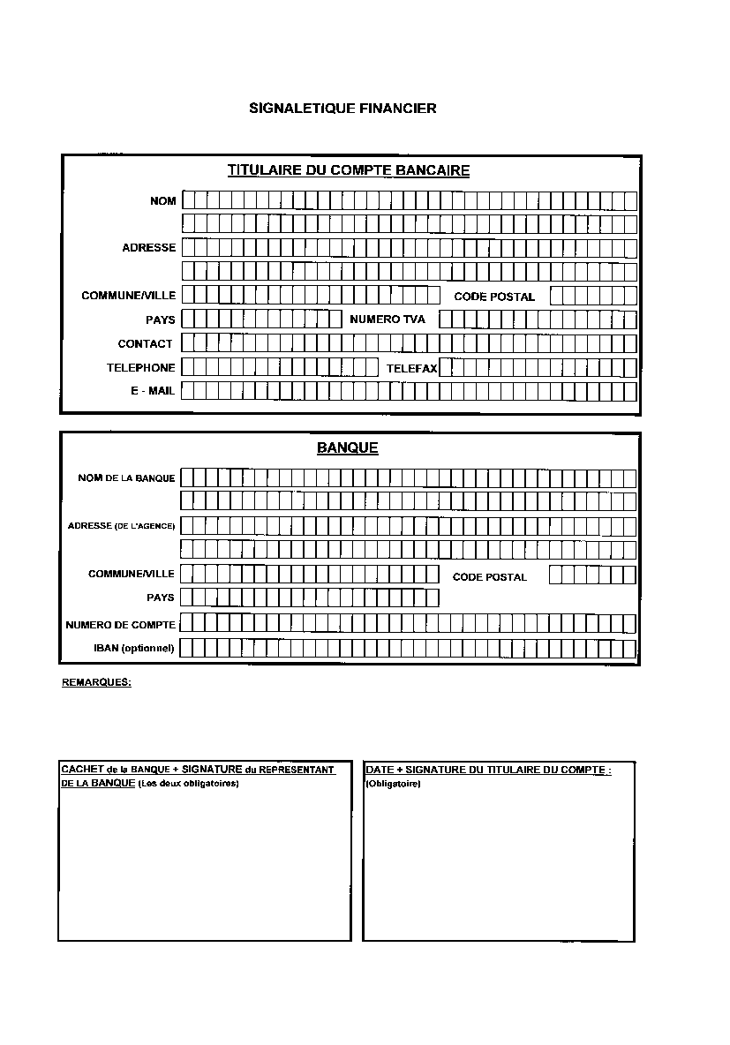

Annex II – Exclusion Criteria Form

Declaration of Honour

The undersigned [name of the signatory of this form, to be completed]:

- in his/her own name (if the economic operator is a natural person or in case of own declaration of a director or person with powers of representation, decision making or control over the economic operator)
or
- representing (if the economic operator is a legal person)

official name in full (only for legal person):

official legal form (only for legal person):

official address in full:

VAT/company registration number:

declares that the company or organisation that he/she represents / he/she:
- is not bankrupt or being wound up, is not having its affairs administered by the courts, has not entered into an arrangement with creditors, has not suspended business activities, is not the subject of proceedings concerning those matters, and is not in any analogous situation arising from a similar procedure provided for in national legislation or regulations;
- has not been convicted of an offence concerning professional conduct by a judgment which has the force of res judicata;
- has not been guilty of grave professional misconduct proven by any means which the contracting authorities can justify;
- has fulfilled all its obligations relating to the payment of social security contributions and the payment of taxes in accordance with the legal provisions of the country in which it is established, with those of the country of ECHA and those of the country where the contract is to be carried out;
- has not been the subject of a judgment which has the force of res judicata for fraud, corruption, involvement in a criminal organisation or any other illegal activity detrimental to the Communities’ financial interests;
- is not a subject of the administrative penalty for being guilty of misrepresentation in supplying the information required by ECHA as a condition of participation in the procurement procedure or failing to supply an information, or being declared to be in serious breach of his obligation under contract covered by the budget.
In addition, the undersigned declares on his/her honour that:
g) he has no conflict of interest in connection with the contract; a conflict of interest could arise in particular as a result of economic interests, political or national affinities, family or emotional ties or any other relevant connection or shared interest;
h) he will inform ECHA, without delay, of any situation considered a conflict of interest or which could give rise to a conflict of interest;
i) he has not made and will not make any offer of any type whatsoever from which an advantage can be derived under the contract;
j) he has not granted and will not grant, has not sought and will not seek, has not attempted and will not attempt to obtain, and has not accepted and will not accept any advantage, financial or in kind, to or from any party whatsoever, constituting an illegal practice or involving corruption, either directly or indirectly, as an incentive or reward relating to award of the contract.
k) that the information provided to the Agency within the context of this request for offers is accurate, sincere and complete.
l) that, in case of award of contract and if requested by the Agency, he will provide the evidence that he is not in any of the situations described in points a, b, d, e above.
For situations described in (a), (b) and (e), production of a recent extract from the judicial record is required or, failing that, a recent equivalent document issued by a judicial or administrative authority in the country of origin or provenance showing that those requirements are satisfied. Where the Tenderer is a legal person and the national legislation of the country in which the Tenderer is established does not allow the provision of such documents for legal persons, the documents should be provided for natural persons, such as the company directors or any person with powers of representation, decision making or control in relation to the Tenderer.
For the situation described in point (d) above, recent certificates or letters issued by the competent authorities of the State concerned are required. These documents must provide evidence covering all taxes and social security contributions for which the Tenderer is liable, including for example, VAT, income tax (natural persons only), company tax (legal persons only) and social security contributions.
For any of the situations (a), (b), (d) or (e), where any document described in two paragraphs above is not issued in the country concerned, it may be replaced by a sworn or, failing that, a solemn statement made by the interested party before a judicial or administrative authority, a notary or a qualified professional body in his country of origin or provenance.
By signing this form, the undersigned acknowledges that he has been acquainted with the administrative and financial penalties described under Articles 133 and 134b of the Implementing Rules (Commission Regulation 2342/2002 of 23/12/02), which may be applied if any of the declarations or information provided prove to be false.

Date:……………………………..
Full name: ……………………………..
Original signature and stamp:……………………………..

Annex III - Financial and Economic Capacity Overview Form
Financial and Economic Capacity Overview
Currency : EURO | Figures (000)
 | N* (* most recent figures available) | N-1 | N-2
Total Balance Sheet
TRADE DEBTORS
Amounts due by commercial customers
CAPITAL and RESERVES (Equity)
Amounts owned by the company
TRADE CREDITORS
Amounts due to commercial suppliers
SHORT TERM DEBT
LONG TERM DEBT
LIQUIDITY
Bank accounts, cash at hand
About PROFIT & LOSS
TURNOVER
ORDINARY RESULT
EXTRAORDINARY RESULT
INCOME TAX
NET RESULT

You may add any data that you would consider of vital relevance for your organisation and for the understanding of the above figures.
Comments: Please explain BRIEFLY important variations from one year to another if appropriate. In case of negative equity or repeated losses, please explain how the future of the organisation will be ensured.

Annex IV – Contract Reference Form

for Canteen, Catering and Cafeteria Services
Name of candidate
Address
Telephone
E-mail

Reference Contract Description

Name/Description of the Contract:

Address of the Contract:

Value of Contract:

Start/End dates of Contract:

Name of Recipient:

Areas of Services: Canteen □
Catering □
Cafeteria □

I hereby certify the satisfactory execution of the project above, it has been carried out in a professional manner and has been fully completed.

Date:……………………………..
Full name: ……………………………..
Original signature and stamp:……………………………..

Annex V – Statement on Average Annual Permanent Staff Members

Name of candidate
Address
Telephone
E-mail

I hereby certify that over the last three years an average of (indicate number) …….. technically qualified staff has been employed by the company for providing canteen, cafeteria and catering services.

In 2008: ___________________________________

In 2009: ___________________________________

In 2010: ___________________________________

Date:……………………………..
Full name: ……………………………..
Original signature and stamp:……………………………..

Annex VI – Curriculum Vitae

The following curriculum vitae format must be used and filled in and signed, by each person. General information (not applicable to all the sections of the curriculum vitae template below) on how to fill it in can be found at: http://europass.cedefop.europa.eu/europass/home/hornav/Downloads/EuropassCV/CVInstructions.csp



Europass
Curriculum Vitae
Personal information
First name(s) / Surname(s) |  | First name(s) Surname(s)
Telephone(s) |  |  | Mobile:
E-mail
Nationality
Date of birth
Gender
Current job profile
Work experience
Dates |  | Add separate entries for each relevant post occupied, starting from the most recent.
Occupation or position held
Main activities and responsibilities
Name and address of employer
Type of business or sector
Education and training
Dates |  | Add separate entries for each relevant course you have completed, starting from the most recent.
Title of qualification awarded
Principal subjects/occupational skills covered
Name and type of organisation providing education and training
Level in national or international classification

Personal skills and competences
Mother tongue(s)
Other language(s)
Self-assessment |  | Understanding |  |  |  | Speaking |  |  |  | Writing
European level (*) |  | Listening |  | Reading |  | Spoken interaction |  | Spoken production
Language
Language
 | (*) Common European Framework of Reference for Languages http://europass.cedefop.europa.eu/LanguageSelfAssessmentGrid/en
Social skills and competences
Organisational skills and competences
Technical skills and competences
Computer skills and competences
Artistic skills and competences
Other skills and competences

Annex VII – Power of Attorney
Model 1
Agreement / Power of Attorney
(DESIGNATING ONE OF THE COMPANIES OF THE GROUP AS LEADER AND
GIVING A MANDATE TO IT)
We the undersigned:
– Signatory 1 (Name, Function, Company, Registered address, VAT Number)
– Signatory 2 (Name, Function, Company, Registered address, VAT Number)
– …..
– Signatory N (Name, Function, Company, Registered address, VAT Number),
Each of them having the legal capacity required to act on behalf of his/her company, HEREBY AGREE AS FOLLOWS:
In case the European Chemicals Agency awards Contract …. (« the Contract ») to Company 1, Company 2, …, Company N (« the Group Members »), based on the joint offer submitted by them on … ….. for the supply of ….. and/or the provision of services for … (« the Supplies and/or the Services »).
(1) As co-signatories of the Contract, all the Group Members:
(a) Shall be jointly and severally liable towards the European Chemicals Agency for the performance of the Contract.
(b) Shall comply with the terms and conditions of the Contract and ensure the proper execution of their respective share of the Supplies and/or the Services.
(2) To this effect, the Group Members designate Company X as Group Leader.
[N.B.: The Group Leader has to be one of the Group Members]
(3) Payments by the European Chemicals Agency related to the Supplies or the
Services shall be made through the Group Leader’s bank account .[Provide details on bank, address, account number, etc.].
(4) The Group Members grant to the Group Leader all the necessary powers to act on their behalf in connection with the Supplies and/or the Services. This mandate involves in particular the following tasks:
(a) The Group Leader shall sign any contractual documents —including the Contract and Amendments thereto—and issue any invoices related to the Supplies or the Services on behalf of the Group Members.
(b) The Group Leader shall act as single point of contact for the European Chemicals Agency in connection with the Supplies and/or the Services to be provided under the Contract. It shall co-ordinate the provision of the Supplies and/or the Services by the Group Members to the European Chemicals Agency, and shall see to a proper administration of the Contract.
Any modification to the present agreement / power of attorney shall be subject to the
European Chemicals Agency’s express approval.
This agreement / power of attorney shall expire when all the contractual obligations of the Group Members towards the European Chemicals Agency in connection with the Supplies and/or the Services to be provided under the Contract have ceased to exist. The parties cannot terminate it before that date without the Agency’s consent.

Signed in ………… on ……….. ………

Name Name
Function Function
Company Company

Name Name
Function Function
Company Company

POWER OF ATTORNEY
Model 2
Agreement / Power of Attorney
(CREATING THE GROUP AS SEPARATE ENTITY, APPOINTING A GROUP
MANAGER AND GIVING A MANDATE TO HIM/HER)
We the undersigned:
– Signatory 1 (Name, Function, Company, Registered address, VAT Number)
– Signatory 2 (Name, Function, Company, Registered address, VAT Number)
– …..
– Signatory N (Name, Function, Company, Registered address, VAT Number),
Each of them having the legal capacity required to act on behalf of his/her company,
HEREBY AGREE AS FOLLOWS:
In case the European Chemicals Agency awards Contract …. (« the Contract ») to Company 1, Company 2, …, Company N (« the Group Members »), based on the joint offer submitted by them on … ….. for the supply of ….. and/or the provision of services for … (« the Supplies and/or the Services »).
(1) As co-signatories of the Contract, all the Group Members:
(a) Shall be jointly and severally liable towards the European Chemicals Agency for the performance of the Contract.
(b) Shall comply with the terms and conditions of the Contract and ensure the proper execution of their respective share of the Supplies and/or the Services.
(2) To this effect, the Group Members have set up under the laws of ……. the Group
….. (« the Group »). The Group has the legal form of a .….. [Provide details on registration of the Group: VAT Number, Trade Register, etc.].
(3) Payments by the European Chemicals Agency related to the Supplies or the Services shall be made through the Group’s bank account . [Provide details on bank,
address, account number, etc.].
(4) The Group Members appoint Mr/Ms ……. as Group Manager.
(5) The Group Members grant to the Group Manager all the necessary powers to act
alone on their behalf in connection with the Supplies and/or the Services. This mandate involves in particular the following tasks :
(a) The Group Manager shall sign any contractual documents —including the Contract and Amendments thereto—and issue any invoices related to the Supplies or the services on behalf of the Group Members.
(b) The Group Manager shall act as single point of contact for the European Chemicals Agency in connection with the Supplies and/or the Services to be provided under the Contract. He/she shall co-ordinate the provision of the Supplies and/or the Services by the Group Members to the European Chemicals Agency, and shall see to a proper administration of the Contract.
Any modification to the present agreement / power of attorney shall be subject to the
European Chemicals Agency’s express approval.
This agreement / power of attorney shall expire when all the contractual obligations of the Group Members towards the European Chemicals Agency in connection with the Supplies and/or the Services to be provided under the Contract have ceased to exist. The parties cannot terminate it before that date without the Agency’s consent.

Signed in ……... on ……….. ………

Name Name
Function Function
Company Company

Name Name
Function Function
Company Company

Annex VIII – Subcontractor / Letter of Intent

The undersigned: ………………………………………………………………………….

Name of the company/organisation: …………………………………………………….

Address: ……………………………………………………………………………………

Declares hereby the intention to collaborate in the execution of the tasks subject to the above call for tender, in accordance with the terms of the offer to which the present form is annexed, if the contract is awarded to … …. (name of the candidate).

Declares hereby accepting the general conditions attached to the tendering specifications for this call for tender, in particular Art. II.13 of the draft contract in relation with checks and audits.

Full name Date Signature

.......................................................................................................................................

http://eur-lex.europa.eu/Notice.do?val=276169:cs&lang=en&list=419956:cs,419955:cs,419531:cs,419957:cs,285480:cs,276169:cs,&pos=6&page=1&nbl=6&pgs=10&hwords=

